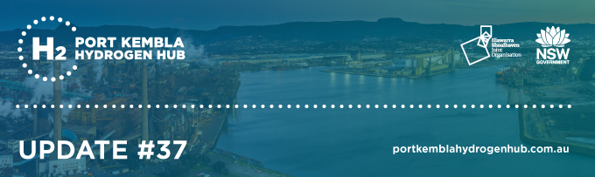

2 July 2026

Greetings hydrogen hipsters from a cold Port Kembla! This Port Kembla Hydrogen Hub Update - Edition #37 contains information on the following key projects and initiatives:
- How $45m in funding will take this Wollongong tech company to the next level - 29 June 2026
- Wollongong hydrogen success story Hysata inks its first major export deal - 19 June 2026
- National Electric Aviation Summit - 3 June 2026
- Illawarra Hydrogen Hub has stalled as BOC's inaction causes fast-track to expire - 3 June 2026
- Illawarra manufacturers get a shot at major low-carbon funding pool - 2 June 2026
- Australia's data centre dilemma: energy boom or bust? - 10 May 2026
- H2 Future Mobility Day #9 - 30 April 2026
- BlueScope CEO says her 100-day plan 'lasted about 100 minutes' due to takeover bid - 30 April 2026
- Twiggy Forrest's Squadron plans a new gas-fired power station at Unanderra - 17 April 2026
- Toyota doubles down on new tech - 2 April 2026

Previous editions of the Port Kembla Hydrogen Hub Update newsletter are available here.
Follow us at Port Kembla Hydrogen Hub on LinkedIn for more updates.

How $45m in funding will take this Wollongong tech company to the next level

29 June 2026

Wollongong company wins $45 million boost for battery tech | Illawarra Mercury | Wollongong, NSW

A Wollongong company has attracted $45 million from the federal government to significantly expand production of a battery technology that improves performance of electric vehicles. Sicona Battery Technologies will use the funding to build a small commercial-scale manufacturing facility to produce its silicon battery materials in Port Kembla, where the company has entered an exclusivity agreement with BlueScope. The funding will boost Sicona's capacity to produce silicon-based anodes by up to 300 times. Founder and chief executive officer Christiaan Jordaan said this was a significant step as the company was currently operating at a small, pilot manufacturing scale. "It's a key stepping stone to the thousands of tonnes of production capacity, which would be defined as full commercial deployment," he said. The expansion is expected to create up to 36 manufacturing jobs.

A silicon-based anode improves battery performance by increasing energy density when used in lithium-ion batteries. "Our technology is a silicon-based battery material that displaces graphite partially or fully," Mr Jordaan said. "So it has a lot of flexibility in how it's used in today's lithium-ion batteries. "It is a materials-based technology, so it can be used interchangeably and can be just plugged into the existing battery factories, by just mixing it in with graphite or taking out graphite entirely." He said this could improve the energy density of batteries by 20 to 100 per cent. In electric vehicles, this leads to longer driving ranges and 40 per cent faster charging times. But the technology has more applications: it can be used in any lithium-ion battery except large-scale energy storage system batteries, meaning anything from drones and laptops to electric scooters and electric mowers.

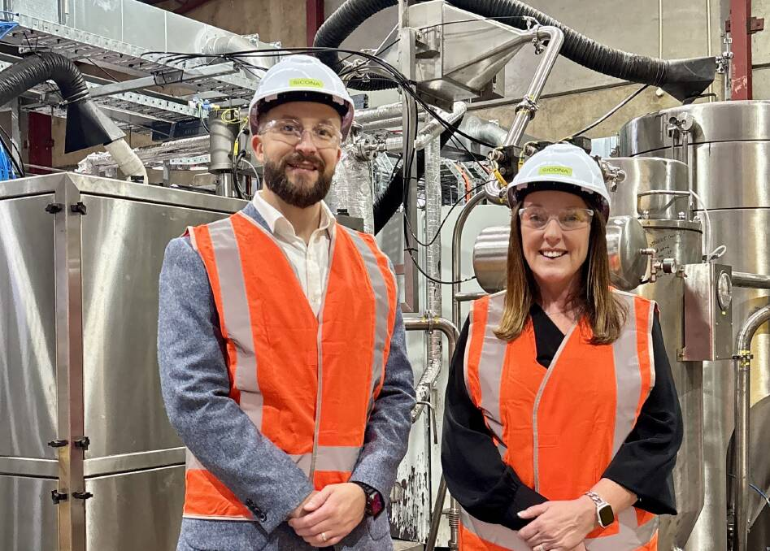
Image: Sicona Battery Technologies founder and CEO Christiaan Jordaan and Cunningham MP Alison Byrnes. Picture supplied

"A quite exciting new application is humanoid robotics and battery-power robotics, where our technology is hugely impactful," Mr Jordaan said. The federal government says its investment in Sicona will strengthen Australia's position in global battery supply chains. "Our region has the skills, capability and drive to lead the clean energy transition and strengthen Australia's advanced manufacturing future, with companies like Sicona, Hysata, Green Gravity, Gravitas and more, working together to put the Illawarra on the world stage," Cunningham MP Alison Byrnes said.

Tim Ayres, the Minister for Industry and Innovation and for Science, said the federal government was supporting domestic, large-scale battery material production. "By backing projects like Sicona, we're ensuring Australia captures more value from its resources while creating jobs, driving innovation, and strengthening economic resilience," Mr Ayres said. For Mr Jordaan, to receive such financial backing that allows the company to make this leap is "huge". "It should be emphasised this is a collective effort by our whole team, our 33 people working in the company," he said. "We're still a small, modest start-up team, but we have phenomenal people working at the company with a lot of dedication to make this happen. "So for me, it's a moment of immense personal pride to see this as a testimony to the impact of our technology and ... the work we've done to get it to this stage." But Mr Jordaan said this was also another starting point. "Now we're really getting stuck into it, now is where things really get exciting and we take this technology to the next level and really grow its impact in the world."

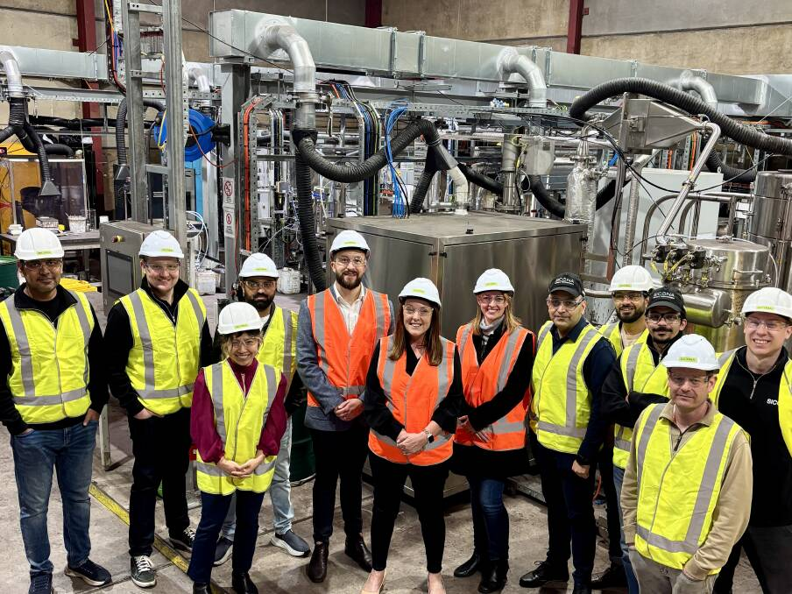
Image: Sicona founder and CEO Christiaan Jordaan and Cunningham MP Alison Byrnes, centre, with members of the Sicona team. Picture supplied

Wollongong hydrogen success story Hysata inks its first major export deal

19 June 2026

Hysata: Port Kembla firm secures major global export deal | Illawarra Mercury | Wollongong, NSW

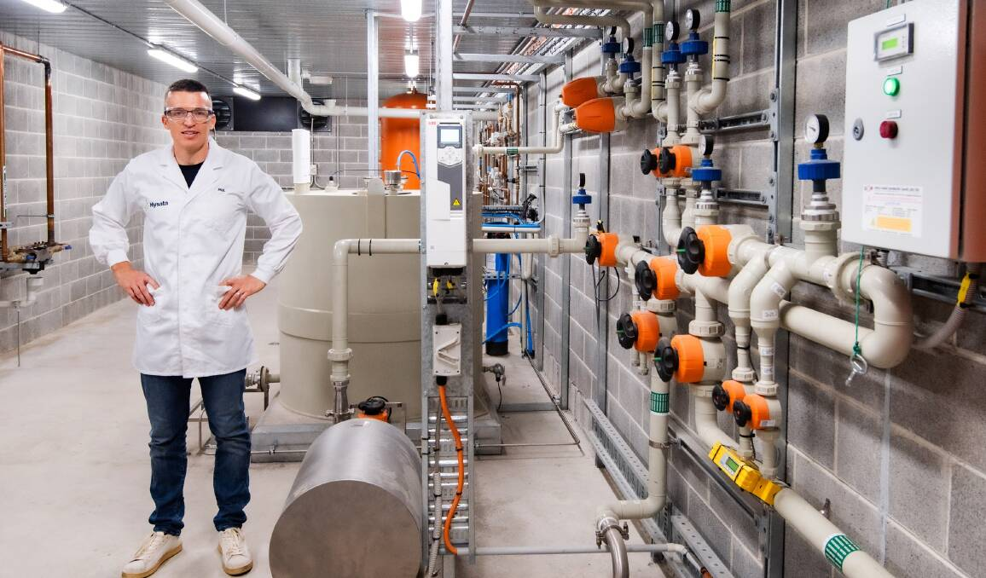
Image: Hysata CEO Dr Paul Barrett at work. Picture supplied

Port Kembla hydrogen firm Hysata has inked its first major export deal in what is a significant milestone for the locally-grown company. Hysata manufactures its breakthrough technology of low-cost electrolysers to split water into hydrogen and oxygen, with "green" hydrogen then able to be used for fuel at a much lower cost than before. It has now signed its first megawatt-scale commercial order, with a highly efficient electrolyser to be delivered to an as-yet-unnamed "significant global customer" early next year. Hysata CEO Dr Paul Barrett said the commercial order was a significant endorsement of the company's technology and a major step forward for the green hydrogen industry. "Electricity is the largest cost component in green hydrogen production, so improving efficiency is the most powerful lever to reduce the costs to our customers," Dr Barrett said. "Our mission has always been to transform the economics of green hydrogen through the world's most efficient, simple and reliable electrolyser. "Securing our first commercial order demonstrates that the market is ready for a new generation of hydrogen production technology."

The taxpayer has contributed significantly to Hysata's establishment, with $15 million from the Clean Energy Finance Corporation and $30 million from the Australian Renewable Energy Agency. More than $170 million has been raised from private investors. Member for Cunningham Alison Byrnes said the funding enabled Hysata to scale up production exactly for orders like this. "Hysata is an innovative local success story," she said.
"Born out of the University of Wollongong, they employ 120 local people and work with local suppliers and partners to create the clean energy technology we need for the future. "I'm so proud of the work they are doing, and absolutely delighted that this has been backed by the Albanese government."

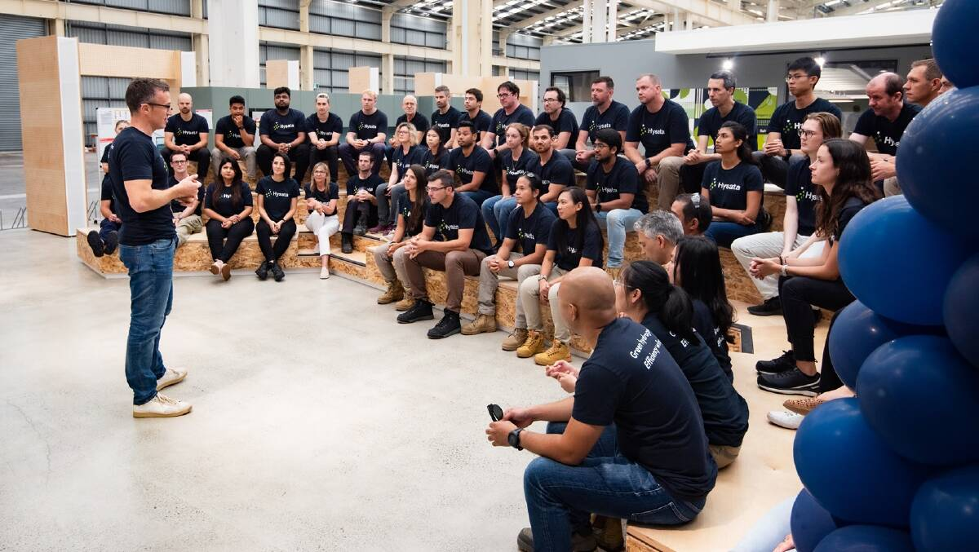
Image: Hysata's staff at a meeting in the company's manufacturing facility at Port Kembla. Picture supplied

Hysata's commercial order follows a successful international demonstration program, including a recent trial in Saudi Arabia with global energy and water infrastructure company Acwa, and the company said it had attracted interest from investors and customers in Europe and the Middle East. Hysata's workforce includes female scientists, engineers and technicians from more than 30 countries, which is a significant source of pride. "You can't scale breakthrough technology without exceptional people, and the best people come from everywhere," Hysata chief people officer Leanne Isabella said. "We have built a team spanning more than 30 countries, including some of the world's brightest women in STEM, underpinned by a high-performance culture grounded in support, honesty, respect, kindness and empathy. "Our culture and range of experience is a big part of why we can deliver."

Ms Byrnes said it showed the renewable energy success stories in the Illawarra were stacking up. "Our region is supporting Australia's clean energy ambitions and proving to be a true leader in innovation and industrial transformation," she said. "Companies like Sicona, Green Gravity, Hysata, Gravitas and more are working together so well to put the Illawarra on the world stage when it comes to clean energy and manufacturing."

National Electric Aviation Summit

3 June 2026

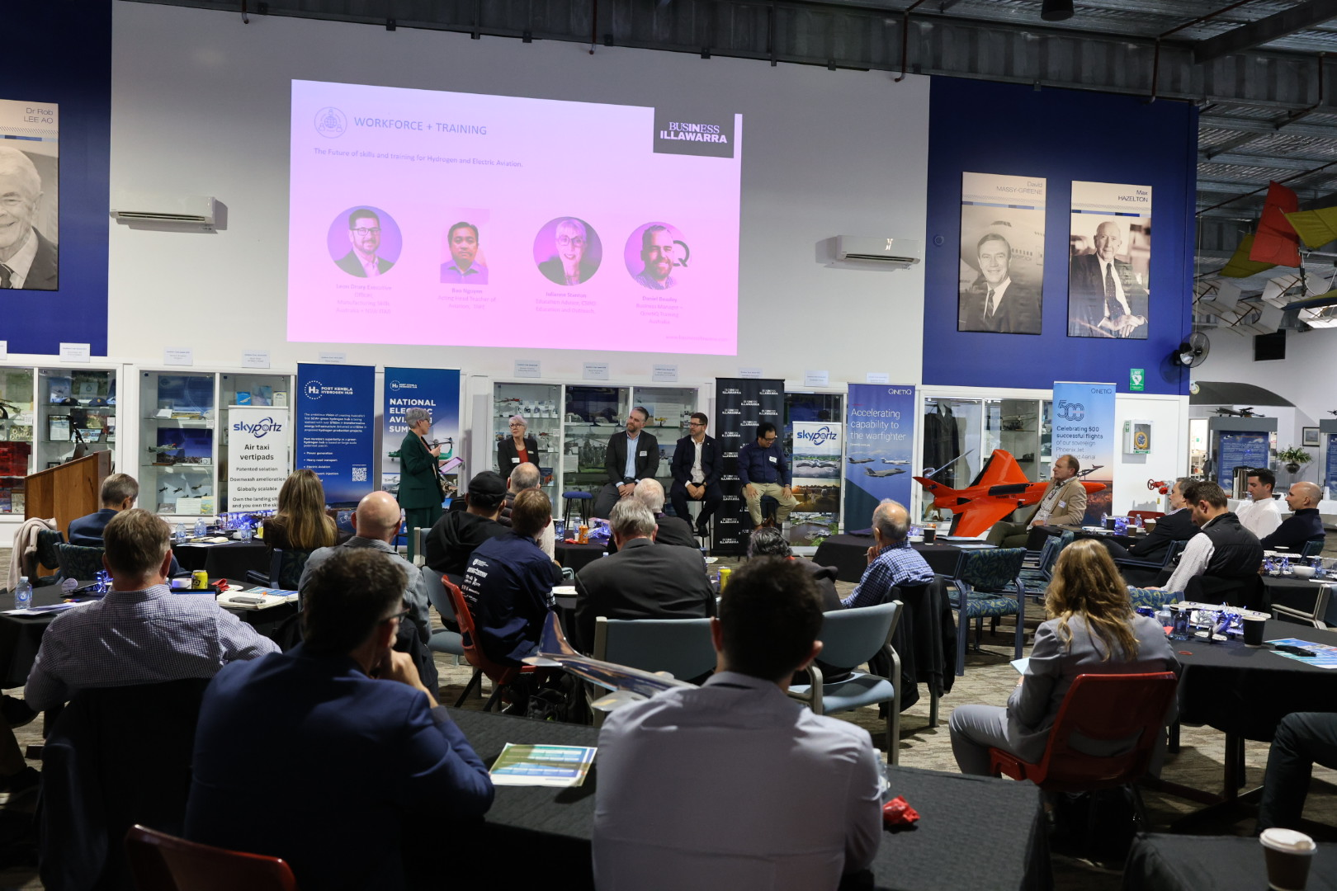
Image: Skills Panel chaired by Business Illawarra CEO Coralie McCarthy

Electric aviation powered by hydrogen is taking off. The inaugural National Electric Aviation Summit was held on the 3 June 2026 at Shellharbour Airport and featured key speakers involved in electric aviation from academia, industry and government. The purpose of the event was to showcase how the Illawarra Shoalhaven region can play a vital role in this new and exciting industry. Keynote speaker Mirjam Wiedemann set the scene explaining the importance of a well-developed ecosystem to support the deployment of electric aviation over the coming decades. Other speakers included David Doral, CEO of Dovetail Electric Aviation that are developing a proprietary zero emissions electric propulsion system that can be retrofitted to a range of small commercial aircraft such as the Cessna C2028 Caravan.

Delegates heard from AMSL Aero CEO Adriano Di Pietro. AMSL Aero are building the third prototype of their bespoke hydrogen powered aircraft that features vertical take-off and landing capabilities. An important area of developing any new sector or industry involves providing the skills required to support its growth. Business Illawarra CEO Coralie McCarthy chaired a panel around the skills issue with representatives from TAFE NSW, CSIRO and other training providers.

Local examples of electric aviation also exist. Shellharbour Airport is emerging as Australia’s centre of excellence for the Cessna C208 Caravan aircraft that are used extensively by the skydiving industry. The NSW Government in 2025 awarded a grant to Experience Co to expand its operations at Shellharbour Airport, home for the past 25 years. The grant includes a focus on electrification of the Cessna Caravan platform through Experience Co subsidiary Performance Aviation that performs extensive maintenance and repair work to the C208 Caravan to keep their fleet operational.


Image: Cessna C208 Caravan introduced in 1984 with over 3,000 units produced is popular with skydiving operators

Illawarra Hydrogen Hub has stalled as BOC's inaction causes fast-track to expire

3 June 2026

BOC Gas: Illawarra hydrogen project stalls despite funding | Illawarra Mercury | Wollongong, NSW

Another high-profile Illawarra green energy project - BOC's Illawarra Hydrogen Technology Hub - has stalled with no word from the company or the state government about whether it might go ahead. BOC Gas was promised $28.5 million in 2023 from the NSW government for its hydrogen project at Cringila but the company has still not decided if it wants to go ahead. The project's status as State Significant Development has now expired due to more than two years of inaction, and BOC will have to reapply if it decides to proceed. An energy expert said it was "odd" as the industry locally, and the Port Kembla Hydrogen Hub, were developing strongly.

The NSW government will not say how much of the taxpayer's $28.5 million has been handed over to BOC already, claiming this information was "commercial in confidence". A spokesman for the Department of Climate Change, Energy, the Environment and Water would only say there had been a "small payment”. The Mercury asked BOC Gas, through its parent company, the UK-based Linde Group, if it was any closer to a decision on whether to go ahead. "BOC is continuing to evaluate options to progress the Illawarra Hydrogen Hub towards its Final Investment Decision," a Linde spokesman said. This position has changed little since September 2023, when the funding was announced to help BOC build a 10 megawatt electrolyser at Cringila to make hydrogen to power up to 40 heavy vehicles. It was accepted on the fast track as State Significant Development but this has now lapsed as two years had passed without further progress. "We are aware that this particular approval has lapsed," the Linde spokesman said. "It is one aspect of the project development process that remains subject to ongoing evaluation with the NSW government."

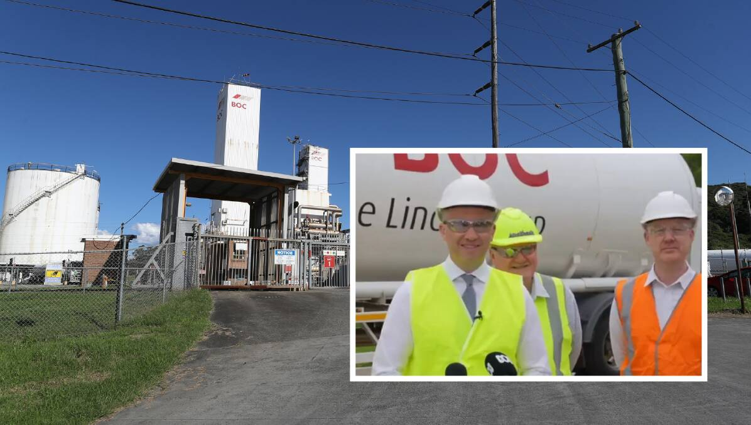
Image: BOC's Cringila site (main picture) and (inset) then energy minister Matt Kean (left) and BOC Gas managing director Theo Martin (right) making the funding announcement in 2023.

Hydrogen strong in Port
Professor Ty Christopher, director of the Energy Futures Network at the University of Wollongong, said the BOC project's inaction was curious as there was good momentum in the hydrogen industry in the region.
"I'm highly surprised why the BOC Gases project basically has stalled, because there's so much momentum going on in other hydrogen areas within our region at the moment," he said. "It seemed to me to be 'pushing on an open door' to proceed with the BOC Gases project as well. "I suspect it must be something within BOC Gases and their own corporate machinations [and], funding.

"It just really strikes me as odd that that hasn't gone ahead with the pace that it could have."
The title of "Illawarra hydrogen technology hub" being used for BOC's project is somewhat misleading as Professor Christopher said there was significant momentum nearby at what was called the Port Kembla Hydrogen Hub. "It can't be driven by a general regional lack of interest, because the regional momentum is very strong in this area," he said. "The evidence of it is there with Hysata, with what's going on with the renewable fuel centre of excellence, leaning into things out at our regional airport." At Port Kembla, Hysata is growing its manufacturing facility for highly efficient hydrogen electrolysers, aided by about $36 million in Australian government funding. This facility was also helped to get its start with $1.5 million from the NSW government in December 2023. Hysata's aim is to reach the scale of one gigawatt production.

When BOC's Cringila project was announced it was said that the longer-term aim was to have 650 megawatts of electrolyser capacity, which could abate 716,514 tonnes of emissions by 2030 by expanding supply to decarbonise steel, glass and cement production in the region. The DCCEEW spokesman said only a small amount had been paid to BOC. "BOC Limited was awarded $28.5 million to progress the Illawarra Hydrogen Technology Hub project as part of the NSW Government's Hydrogen Hub Initiative," he said. "Funding for the project is contingent on meeting milestones. A small payment has been paid to BOC in line with an early milestone for the project. "Work has been undertaken to assess the future of the project, including detailed technical and commercial analysis."

BOC's hydrogen hub falling through would be another letdown for major renewable energy efforts in the Illawarra. The Illawarra Offshore Wind Zone has sunk as the only developer still interested walked away in July 2025. And the Illawarra Renewable Energy Zone, a NSW government initiative, was redefined last year as an "urban" zone of household solar panels linked to batteries, and no mention of large-scale generation. Renewable energy generation efforts have instead been focused on the west of the state.

Illawarra manufacturers get a shot at major low-carbon funding pool

2 June 2026

Illawarra manufacturers get a shot at major low-carbon funding pool | Illawarra Mercury | Wollongong, NSW

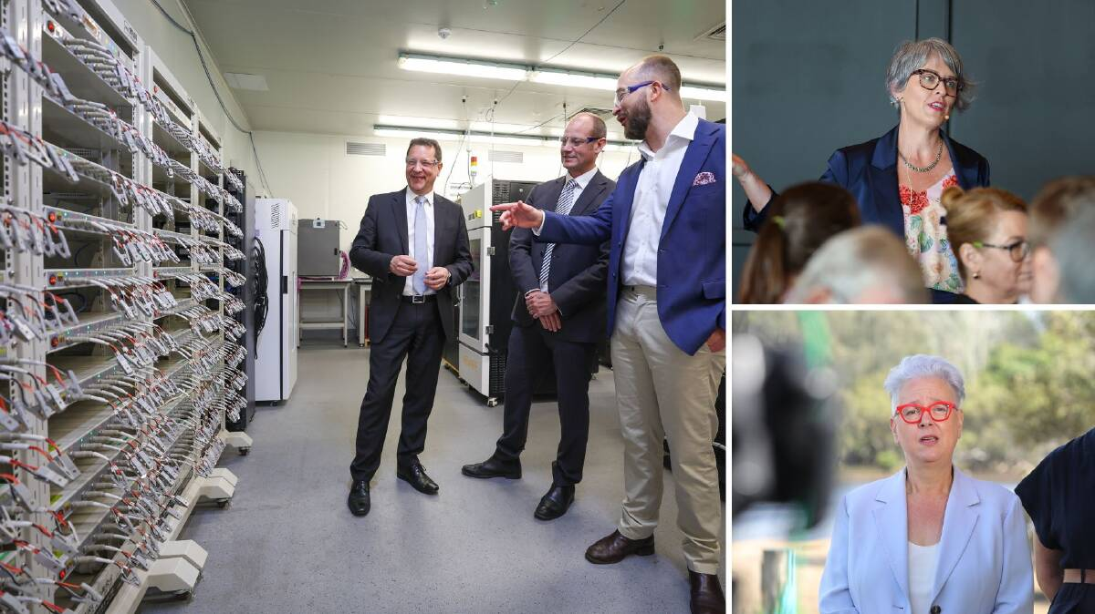
Image: Left, Member for Wollongong Paul Scully, BlueScope Head of Property Development Michael Yiend (striped tie), Sicona Battery Technologies CEO Christiaan Jordaan (blue jacket) at the Sicona Battery Technologies laboratory in North Wollongong, top right, Business Illawarra director Coralie McCarthy, bottom right, Minister for Climate Change and Energy Penny Sharpe. Left and top right picture by Adam McLean, bottom right picture by Robert Pee

Illawarra manufacturers are being called on to apply for a share of $225 million from the state government in a boost for low-carbon manufacturing. The grants are being targeted towards supporting commercial and construction-ready projects which can expand local production, attract private investment and create skilled jobs. Minister for Climate Change and Energy Penny Sharpe said the state government had already "supported the creation of around 1000 jobs, and this boost will power the next wave of industry and opportunity in the Illawarra and across NSW". "This additional funding will help ensure NSW does not just import technology, but builds more of it locally to benefit communities and workers," she said.

Funding from the NSW government has already supported projects in energy storage, battery technology and hydrogen production, including $1.5 million for Hysata for a hydrogen electrolyser trial, more than $1.6 million for Sicona for a pilot plant, and $250,000 for Green Gravity to support gravity energy storage technology. "Wollongong is one of the state's biggest industrial hubs, so this investment in low-carbon manufacturing is a great opportunity for businesses to expand and innovate," member for Wollongong Paul Scully said. "This builds on previous rounds, which have helped to create more than 50 jobs while supporting innovations in energy storage, battery technology and hydrogen production."

'Major opportunity'
Industry group Business Illawarra backed the investment and called it a "major opportunity to strengthen the region's industrial base". "The Illawarra has the skills, infrastructure and industrial heritage to lead in this next generation of manufacturing," Business Illawarra director Coralie McCarthy said. "This is exactly the type of targeted investment we need to help local businesses grow, diversify and compete in a changing global economy." Ms McCarthy said businesses in the Illawarra were well positioned to take advantage and secure the funding. "We are already seeing local success stories in hydrogen, battery technology and energy storage, and this next round creates a real opportunity to build on that momentum," she said. "The key now is ensuring local businesses are aware of the opportunity and supported to put forward strong, investable projects." Ms McCarthy said this next round presents a clear opportunity for more Illawarra businesses to expand and diversify. "The program requires private co-investment, which is exactly what we need to unlock growth, drive innovation and accelerate new industries across the region," she said.
"This is about backing the businesses that will drive the Illawarra's next chapter and continuing to position our region at the forefront of clean energy and advanced manufacturing," Ms McCarthy said.

Australia's data centre dilemma: energy boom or bust?

10 May 2026

Australia's data centre dilemma: energy boom or bust? | Illawarra Mercury | Wollongong, NSW

Australia's tech future hums and flashes inside hundreds of buildings across the country. Drives perched on top of one another, stacked into racks and organised into long rows; the metal boxes delivering vital information, processing demands and answering artificial intelligence queries. More than 270 data centres are operating or planned around Australia, reaching from Darwin in the north to Hobart in the south, and spanning Geraldton in Western Australia to Queensland's Gold Coast. But as the global race to establish more centres in Australia gains momentum, technology and environmental experts have questioned whether the nation can support their high energy and water demands.
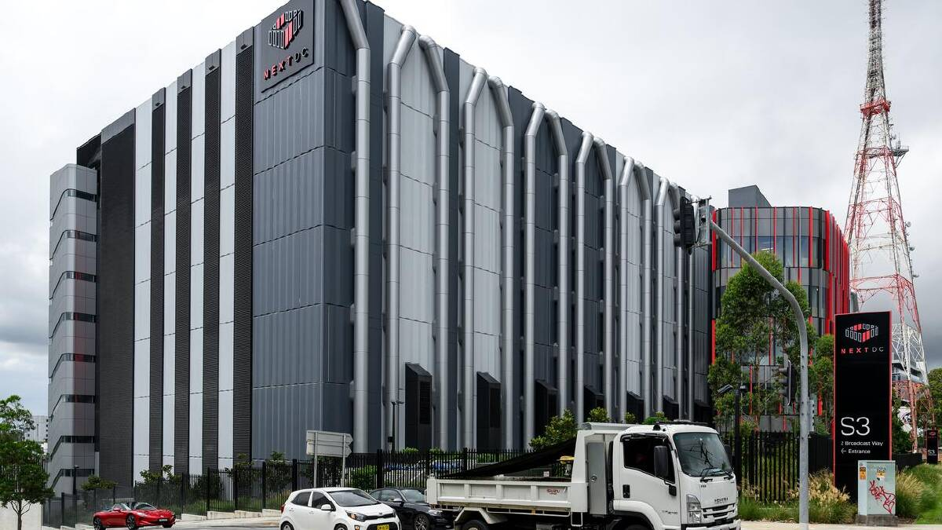
Image: The near-completed multibillion-dollar NEXTDC S7 Sydney data centre is one of 270 across Australia. (Steven Markham/AAP PHOTOS)

If managed poorly, they warn, data centres could force up the price of electricity, strain Australia's water supply and occupy land needed for housing. But if planned well, the technology may deliver unexpected benefits, including more renewable energy projects, support for local innovation and employment in the tech sector and in regional areas. Growing demand for Australian data centres was underlined recently by Microsoft, whose visiting chief executive Satya Nadella made a $25 billion, three-year commitment to building digital infrastructure Down Under. It comes as Google reportedly weighs up a $20 billion investment, after Amazon pledged $20 billion to expand its local data centres. CDC Data Centres has also announced a $3.1 billion facility for Sydney in addition to its existing 200MW campus at Eastern Creek, in the city's west. Australia's biggest data centre developer, NextDC, also has a near-completed $7 billion facility in the suburb that will boast ChatGPT maker OpenAI as its anchor tenant. Australia has become a magnet for AI infrastructure investments, UNSW AI Institute chief scientist Toby Walsh says, due to a mix of economics and geography.

"It's a good business and Australia is a good place to host that business because we can run them on renewables, we've got plentiful land to build them on, we can serve not just the data needs of Australia but those of the Pacific Rim," he says. "There is benefit to us but it has to be done in a responsible way and we should be demanding that they all run on completely renewable energy, that they're all water-zero, that they don't use land that would be better used for housing or agriculture."While data centres provide quick access to processing power needed to fuel AI tools and other innovations, they also consume huge amounts of energy and water.
In a report, Oxford Economics Australia predicted data centres would grow at a rate of 25 per cent and consume 34.5 terawatt hours of power by 2050, or 12 per cent of energy in the National Electricity Market. While estimates of their water consumption remain up for debate, Sydney Water calculates data centres could consume 25 per cent of its drinking supply by 2035.

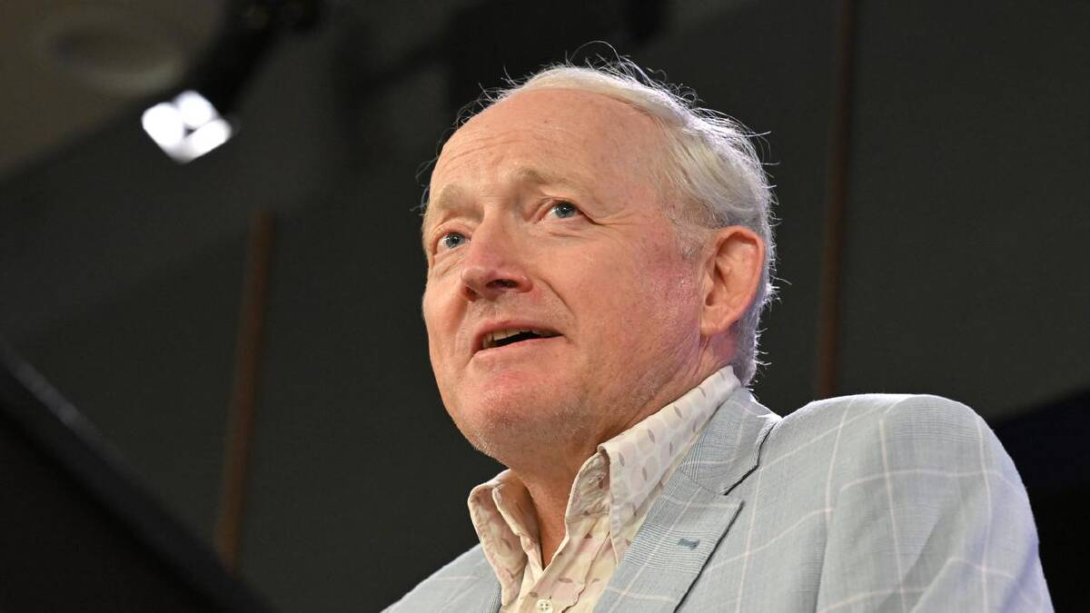
Image: Infrastructure needs should be balanced with environmental and social concerns, says Toby Walsh. (Mick Tsikas/AAP PHOTOS)

Environmental concerns should not be dismissed in the name of innovation, Prof Walsh says, and developmental approvals should be scrutinised carefully. "We should be driving a hard bargain and I'm not sure we're driving a hard enough bargain now," he tells AAP. "Politicians love to stand in front of a new brownfield site with a spade and say we're going to put a data centre here but we should think beyond just the announcement to the industry afterwards." To address concerns, the federal government released National Data Centre Expectations for new developments, designed to work alongside national, state and territory laws.

The five expectations range from supporting Australia's renewable energy transition and using water sustainably to investing in local jobs and strengthening homegrown capability. Adding environmental conditions to their development could ensure data centres bring fewer challenges to Australia, Clean Energy Finance director Tim Buckley says, and deliver unexpected upsides. "It's been really important that the federal government has said we want you to solve the problems you're creating before we approve your projects," he says. "They can be clearly told if you bring your battery, your solar and your wind project and your (desalination) plant with you, the chance you're getting approved is really high."

If given clear renewable energy requirements, data centres could trigger a new wave of energy projects, Mr Buckley says, and provide the necessary financial support to encourage investments from other firms. Amazon Australia, for example, recently signed nine power purchase agreements with battery projects and wind and solar farms, adding 430 megawatts of renewable energy to the grid. "Data centres done right could actually be a big part of the solution for decarbonisation," he says. "I'd be happy to be a fanboy of data centres if they enable billions and billions of dollars in new infrastructure investment in decarbonisation." While energy and water usage remain a concern for many, Swinburne University engineering professor Mehdi Seyedmahmoudian says some issues can be solved by moving their location. Not all data centres need to be built in cities, he says, and they can sit alongside renewable energy projects or water sources. "One of the good things about data centres is they are manageable because we can locate them in different places in Australia," he says. "It's not like transportation that you have to actually charge your car in urban areas."

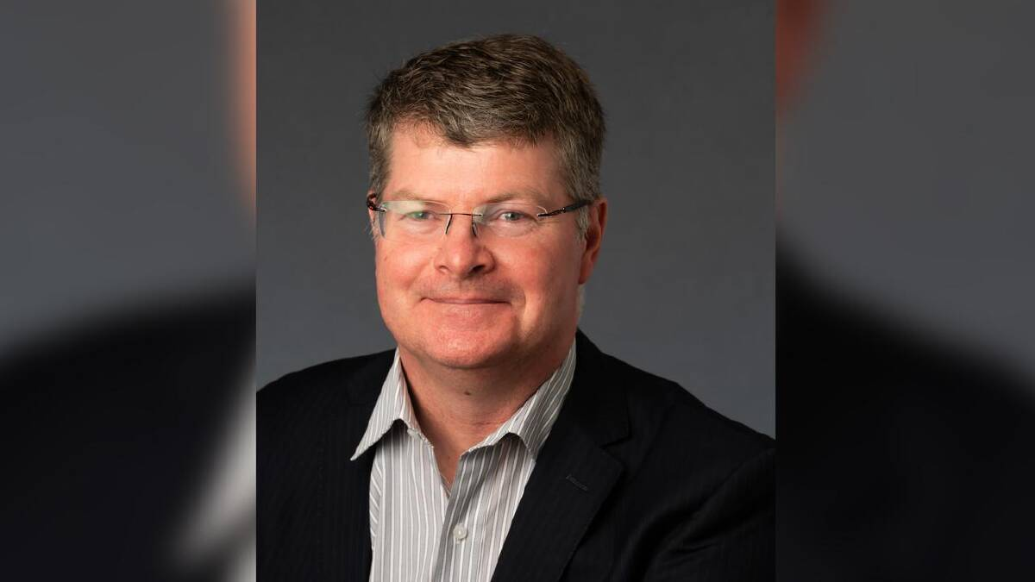
Image: Tim Buckley: adding environmental conditions could ensure data centres bring fewer challenges. (PR IMAGE PHOTO)

While building so many facilities in a short time could strain Australia's workforce, Prof Seyedmahmoudian says it could also accelerate the transformation of our energy system and tech sector and ensure Australian research can be pursued and commercialised here. "We can actually grow these technologies in our country, and we can be one of the world leaders rather than relying on international partners," he says. "Data centres, although they are putting the pressure on the grid, they are the essential parts of our energy digitalisation road map."

Future Mobility Day #9

30 April 2026

Port Kembla is at the forefront of Australia’s decarbonisation of heavy road transport powered by hydrogen. The H2 Future Mobility Day #9 online event held on the 30 April 2026 featured speakers from Foton Mobility Distribution, Gastech and Coregas. The event was chaired by Business Illawarra CEO Coralie McCarthy with a lot of discussion and interest around hydrogen given the current price spike in the price of diesel. Foton’s Iain Dorward gave an update on the KRW Hydron prime mover powered by a hydrogen fuel cell. The prime mover has recently completed successful trials in Queensland.

Launched last May at Port Kembla, Gastech’s innovative ControlR system can help decarbonise existing fleets of diesel-powered prime movers. David Scrimshaw, CEO of Gastech discussed how the ControlR system can be retrofitted to any prime mover, thereby providing a decarbonisation pathway for existing fleets. Wodek Jakubik from Coregas spoke about their H2Station Hydrogen Refueller at Port Kembla, Australia’s first for heavy vehicles. Open since July 2023, the facility has daily capacity of 400kg of hydrogen and operates at 350 bar pressure.
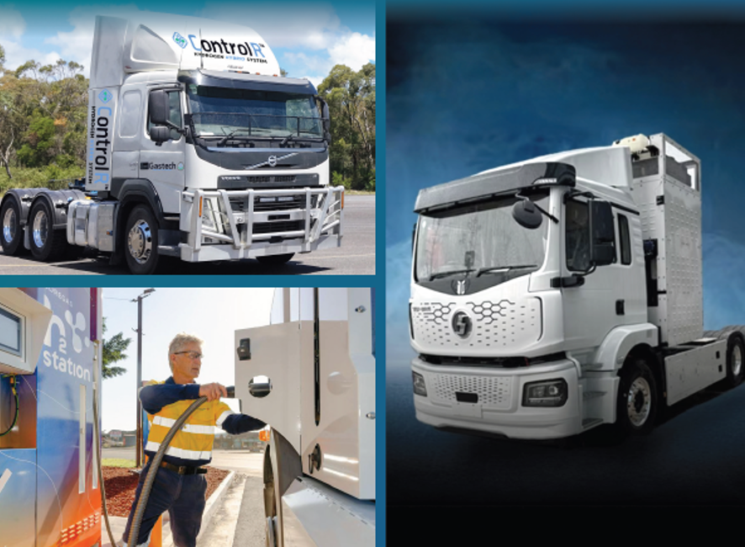
Image: From top left – Gastech’s ControlR system, Coregas H2Station refueller at Port Kembla and Foton Mobility Distribution’s KRW hydrogen prime mover.

BlueScope CEO says her 100-day plan 'lasted about 100 minutes' due to takeover bid

30 April 2026

BlueScope CEO Archibald says takeover bid blew her plan apart | Illawarra Mercury | Wollongong, NSW

BlueScope chief executive Tania Archibald has said her "carefully crafted" 100-day plan upon taking the top job "lasted about 100 minutes" because of a major takeover bid. In a speech to the Melbourne Mining Club on Wednesday Ms Archibald Ms Archibald said the technology from BlueScope's green steel pilot in Western Australia would be shared with the industry, not held as its own property. But before that she got straight down to addressing the "multi-billion-dollar elephant in the room". The Port Kembla steelmaker has twice rejected the takeover bid from media mogul Kerry Stokes' SGH Group and US firm Steel Dynamics, first at a price that valued BlueScope at $13.2 billion, then again after the offer was upped to $14 billion.

Ms Archibald officially took over from former CEO Mark Vassella on February 1, in between the two offers. "I've been CEO of BlueScope for 12 weeks now and like most new CEOs before day one, I had a carefully crafted first 100-day plan," Ms Archibald said. "It lasted for about 100 minutes. "In my 30 years in the steel industry if there's one thing I've learned, it is to expect the unexpected." Steel Dynamics has recently criticised what it called BlueScope's silence over the bid, but Ms Archibald said the company's position had been made "very clearly": the bid was too low. "I can only reiterate that we're open to any proposal that genuinely reflects BlueScope's fundamental value," she said.
"No such proposal has been received. "And we're certainly not sitting around waiting for one to turn up." There have been reports that BlueScope's major shareholders have written to both the prospective buyer and the target making it clear they want a deal at $34 per share. The second rejected offer valued their stock at $32.25. BlueScope rejected the first bid as "cheap" and "opportunistic" and was not moved much more by the second.

Green steel tech would be shared
Ms Archibald moved quickly on to efforts to reduce carbon emissions from the steel industry, and said the technology it was working to advance would be shared with the rest of the steel industry.
The BlueScope boss said Direct Reduction Iron (DRI) technology was the best option in Australia - powered by burning gas. "Natural gas-based DRI alone could give an immediate 60 per cent reduction in emissions at our Port Kembla steelworks," Ms Archibald said.

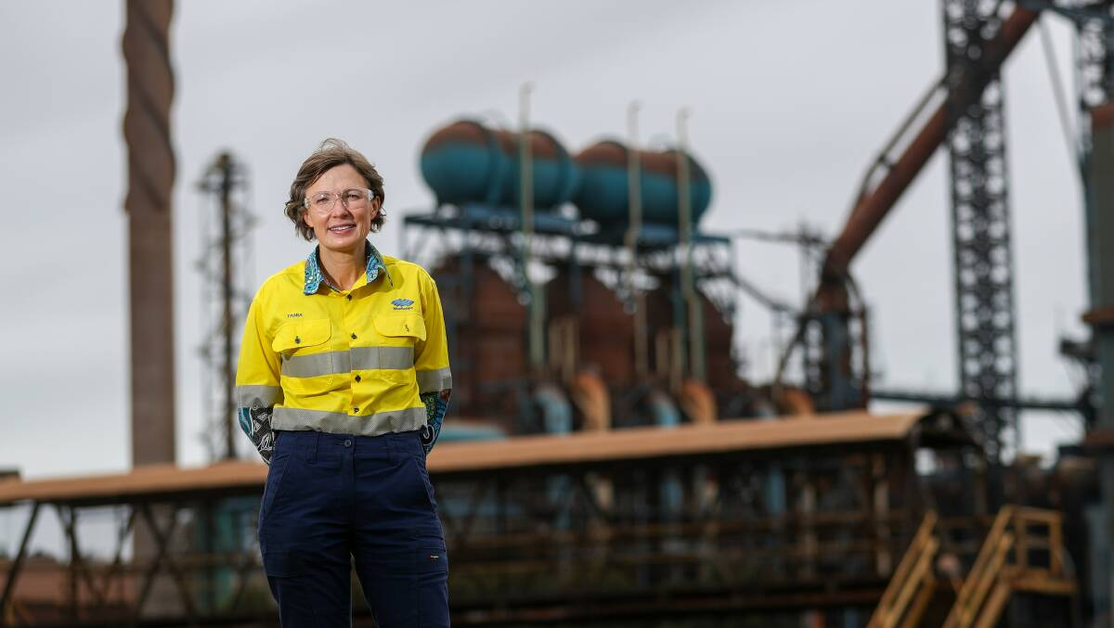
Image: BlueScope CEO Tania Archibald at Port Kembla in 2024. Picture by Adam McLean

"Ultimately that could be displaced by green hydrogen - which gets you an 85 per cent reduction in emissions - but green hydrogen is a very long way from commercial reality, so for now we're very much focused on a natural gas-based DRI option with hydrogen-ready capability." BlueScope is working on a pilot project called NeoSmelt which involves an electric arc furnace combined with DRI technology - in East Rockingham, south of Perth. It's a joint venture with iron ore miners BHP and Rio Tinto and gas giant Woodside, but while the project's feasibility study was valued at $45 million a final investment decision on whether to go ahead will not be made until late this year.

The project has already been given almost $100 million from taxpayers: $75 million from the WA government and almost $20 million from the federal Australian Renewable Energy Agency (ARENA).
Ms Archibald said the project was "fundamentally different" to what the rest of the steel industry was doing, as it would be aimed at influencing decisions in the 2030s about whether to reinvest in blast furnaces. "What is not fully appreciated, but is very important to understand, is that our aim with NeoSmelt is not to restrict access to the technology or IP [intellectual property] produced by the project," she said "This project is structured as technology proliferation - not IP capture. "The NeoSmelt technology will be made available to all steelmakers with the explicit intent to influence 2030s blast furnace reinvestment decisions and accelerate adoption of the technology globally.
"Proliferation of the technology has the potential to cut hundreds of millions of tonnes of greenhouse gas emissions if adopted by integrated steelworks globally.”

Current made in Australia
Ms Archibald said without cheaper gas there would be no "future made in Australia" for manufacturing. That was why BlueScope led the campaign for a domestic gas reservation, which had a win when the federal government's review recommended establishing such a system. But "we're not so misguided as to call victory", Ms Archibald said. "As with all complex policy reforms, the devil will be in the detail," she said. "I won't labour that detail today, but if I had to give a headline it would be that domestic reservation must get the delivered price of gas down to $8-$10/GJ to restore Australia's competitive position. "And that needs to include a price mechanism that decouples domestic prices from LNG netback now and into the future. "I appreciate those numbers put a shiver down a few people spines - in particular the LNG industry. "As my predecessor Mark Vassella called out last year - there is no zero-sum cost solution to this problem. "But it is staring at us and we must address it to avoid a hollowing out of our industrial base. "There is no Future Made in Australia unless we have a current made in Australia."

Twiggy Forrest's Squadron plans a new gas-fired power station at Unanderra

17 April 2026

Unanderra gas-fired power station planned by Squadron Energy | Illawarra Mercury | Wollongong, NSW

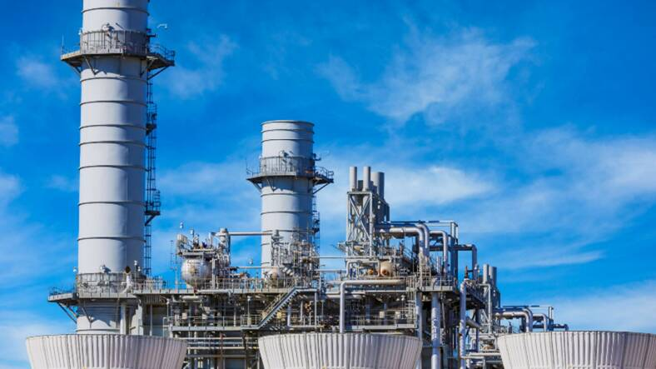
Image: A gas-powered power plant would be for 'firming' supply, Squadron says.

Squadron Energy says the gas-fired power station it wants to build in Unanderra is for "firming" electricity supply in times when renewable power generation can't meet demand. Andrew "Twiggy" Forrest's company, fresh from building the Port Kembla gas terminal, has passed the first hurdle towards having the Unanderra project approved, having it accepted as State Significant Development.

It would be built within the Illawarra's Renewable Energy Zone (REZ) but uses fossil fuel - natural gas - that would be burned to power turbines which generate electricity. Up to eight turbines, each within enclosures with exhaust stacks, would be built on the site which is part of Shinagawa Refractories' land at 23 Glastonbury Ave. With a notional capacity of 300-400MW, the plant would take gas from Jemena's Eastern Gas Pipeline and deliver power to the grid via the adjacent Endeavour Energy Springhill substation.

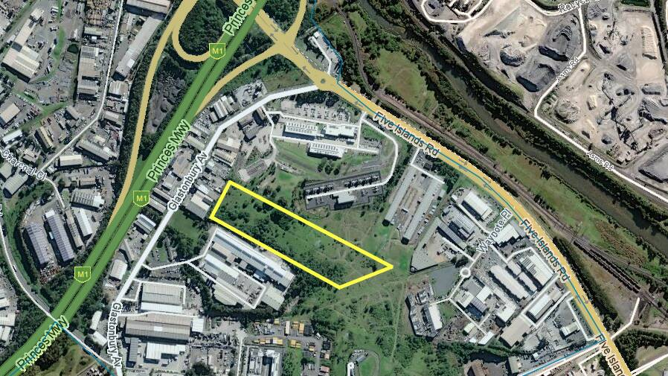
Image: Yellow outline shows the approximate site for the power plant. Map from WhereIs

Squadron said a gas firming plant was not designed to run all the time and would be used when wind, solar, and battery output drops, or demand rises. A spokesperson told the Mercury the plant was designed to only run about 40 days a year, or about 1000 hours annually. "We have deliberately designed the facility to play an important but transitional role supporting the reliability of Australia's electricity system, as more renewables and batteries are built and coal is phased out," the Squadron spokesperson said. "Squadron Energy is committed to accelerating Australia's clean energy transition by delivering large-scale renewable energy projects backed by firming.
"Our proposed gas-powered Illawarra Firming Power Station (IFPS) will provide backup electricity during periods when wind and solar generation are not sufficient - keeping the power system reliable."

The NSW government in May last year redefined the Illawarra REZ towards being an "urban renewables zone" with all mentions of large-scale generation capacity in the region removed. This coincided with the sinking of plans for an Illawarra offshore wind energy industry - while the offshore wind zone was declared by minister Chris Bowen, the last remaining developers interested in the Illawarra have dropped out or left the country altogether. Squadron has said construction on its Port Kembla gas terminal has been completed and the terminal, which would import natural gas, is due to come online in 2028, but it may be able to start operation in 2027 if it is needed for the state's power supply.

Toyota doubles down on new tech

2 April 2026

Pump it up: former PM calls for action on hydropower | Illawarra Mercury | Wollongong, NSW

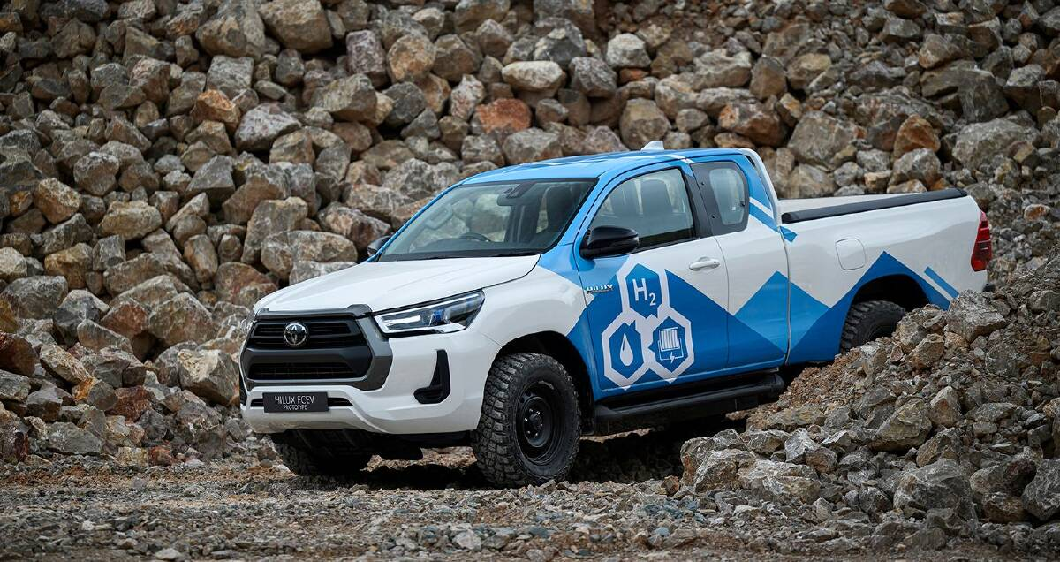
Image: 2024 Toyota HiLux FCEV prototype.

Toyota is one the biggest advocates for hydrogen as a fuel source for vehicles, but it's now focusing its efforts as the mass-market take-up, especially in the passenger car space, still lags. As reported by Nikkei Asia, the Japanese carmaker is doubling down on implementing its hydrogen fuel cell (FCEV) technology in commercial vehicles, like trucks. The reason for this is that demand for hydrogen-fuelled passenger cars is dwindling. Toyota is working with many partners in order to implement and scale its hydrogen fuel cell commercial vehicles. One example is the Japanese carmaker is working closely with the Japanese Government to use hydrogen fuel cell trucks and develop a refuelling station network. "I truly believe now is the time to accelerate our hydrogen initiatives together with partners. Let's change the future with hydrogen," said Toyota Hydrogen Factory President Mitsumasa Yamagata to Nikkei Asia. Many carmakers have shunned hydrogen as a viable fuel source. Examples include Volkswagen, Stellantis and General Motors.

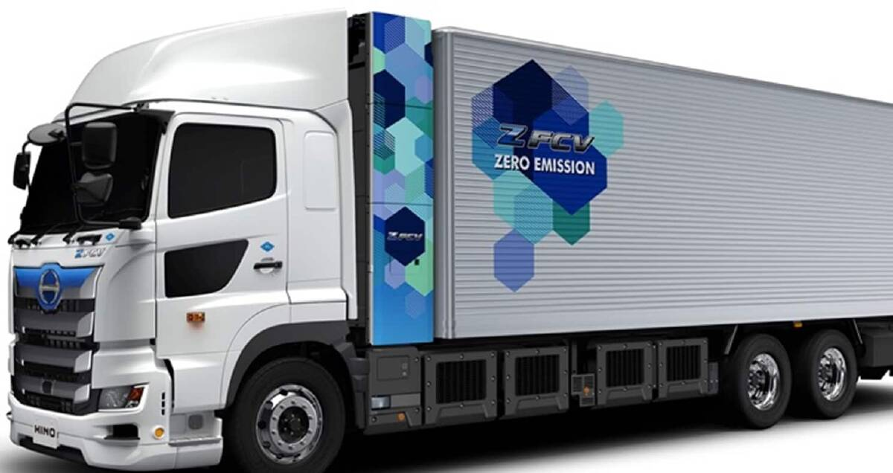
Image: 2026 Hino Profiz Z FCV.

Reasons for this vary but include the high costs associated with developing FCEV technology and producing hydrogen, as well lacklustre refuelling infrastructure, among others. Toyota, along with other brands like BMW and Hyundai are some of the few that have continued development in this space. The Japanese carmaker has been preaching its multi-pathway strategy for decarbonisation for years now and includes continued development in internal-combustion, hybrid, battery electric and hydrogen powertrain technologies.

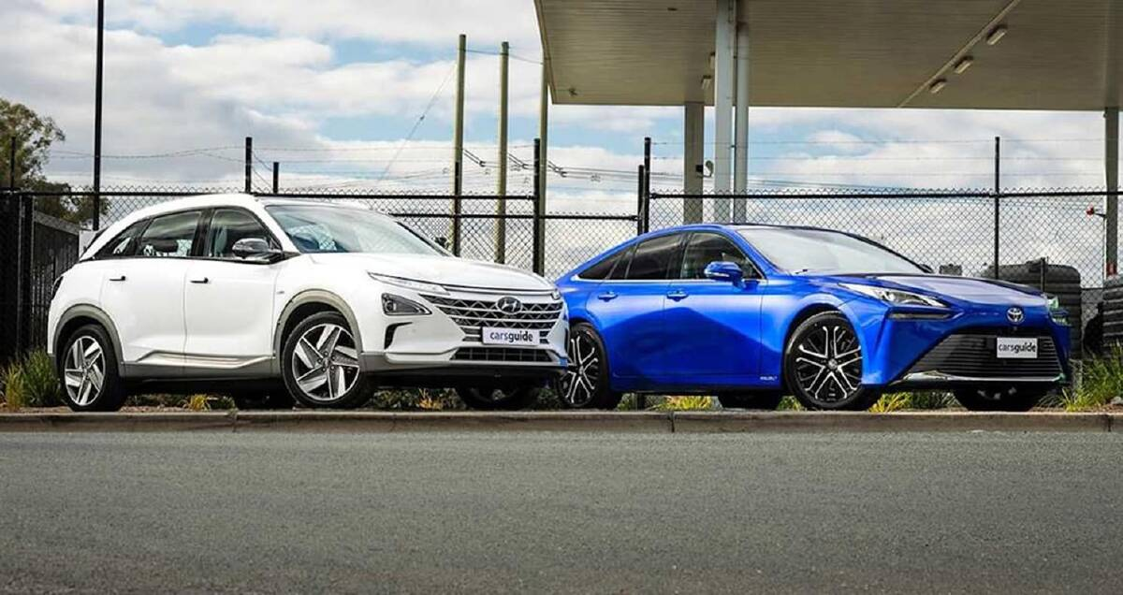
Image: 2023 Hyundai Nexo (left) and Toyota Mirai (right).

Toyota currently has one FCEV truck in the form of the Hino Profiz Z FCV as Hino is part of the Toyota Group. It uses two fuel cell stacks from the Toyota Mirai FCEV liftback that have been customised for heavy-duty commercial use. Hino claims this FCEV truck has a driving range of around 650km when fully loaded and refuelling takes between 15 and 30 minutes.

As it currently stands Toyota doesn't offer any FCEV vehicle to the public in Australia. The Mirai is only offered to select fleets through lease agreements. However, the Japanese carmaker has previously confirmed it plans to introduce a FCEV version of the HiLux in Australia in 2027. This will be available to the public but will be aimed at commercial fleets, much like the recently priced HiLux BEV. In Australia there are very few hydrogen refuelling stations currently. There are several initiatives and funding from state governments being put forward to scale this. One includes the $20 million Hume Hydrogen Highway initiative from the Victorian and New South Wales Governments to connect Melbourne and Sydney with around four refuelling stations along the Hume Highway.

Contact
The Port Kembla Hydrogen Hub is funded by the Illawarra Shoalhaven Joint Organisation (ISJO) and supported by the NSW Government. For further information, please contact Jessica Young, Port Kembla Hydrogen Hub Facilitator by email: info@portkemblahydrogenhub.com.au. Previous editions of the Port Kembla Hydrogen Hub Update newsletter are available here.

